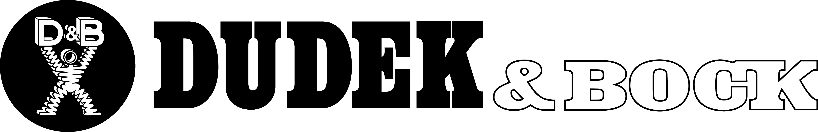

COVID-19 Exposure Prevention, Preparedness,
and Response Plan

PURPOSE

The purpose of this plan is to outline the steps that we can take to reduce the risk of exposure to COVID-19. The plan describes how to prevent worker exposure to coronavirus, protective measures to be taken in production and office areas, personal protective equipment and work practice controls to be used, cleaning and disinfecting procedures, and what to do if a worker becomes sick.

Dudek & Bock takes the health and safety of our employees very seriously. With the spread of the coronavirus or “COVID-19,” a respiratory disease caused by the SARS-CoV-2 virus, we all must remain vigilant in mitigating the outbreak. To promote safety in our operations, we have adopted this COVID-19 Exposure Prevention, Preparedness, and Response Plan. Management will monitor available U.S. Center for Disease Control and Prevention (“CDC”) and Occupational Safety and Health Administration (“OSHA”) guidance on the virus.

This Plan is based on currently available information from the CDC and OSHA and is subject to change based on further information provided by the CDC, OSHA, and other public officials. The Company may also amend this Plan based on operational needs.

RESPONSIBILITIES OF MANAGERS AND SUPERVISORS

All managers and supervisors must be familiar with this Plan and be ready to answer questions from employees. Managers and supervisors must set a good example by following this Plan. This involves practicing good personal hygiene and safety practices to prevent the spread of the virus. Managers and supervisors must encourage this same behavior from all employees.

RESPONSIBILITIES OF EMPLOYEES

For the health and safety of all Dudek & Bock employees, everyone must follow this plan. In addition, employees are expected to report to their immediate supervisor(s) if they are experiencing signs or symptoms of COVID-19, as described below. If you have a specific question about this Plan or COVID-19, please ask your immediate supervisor. If the supervisor cannot answer the question, please contact the plant manager.

OSHA and the CDC have provided the following control and preventative guidance to all workers, regardless of exposure risk:

Frequently wash your hands with soap and water for at least 20 seconds. When soap and running water are unavailable, use an alcohol-based hand sanitizer with at least 60% alcohol.

Avoid touching your eyes, nose, or mouth with unwashed hands. Follow appropriate respiratory etiquette, which includes covering your mouth during coughs and sneezes.

Maintain social distancing of 6 feet. NO close contact.

In addition, employees must familiarize themselves with the symptoms of COVID-19:

Coughing

Fever

Shortness of breath, difficulty breathing;

Early symptoms such as chills, body aches, sore throat, headache, diarrhea, nausea/vomiting, and runny nose.

5. New loss of taste or smell.

If you develop a fever and symptoms of respiratory illness, such as cough or shortness of breath, DO NOT GO TO WORK. Call your healthcare provider. Likewise, if you come in close contact with someone showing these symptoms, call your healthcare provider.

PROTECTIVE MEASURES

The Company has instituted the following protective measures:

General Safety Policies and Rules

Any Company employee/visitor/vendor showing symptoms of COVID-19 will be asked to leave our facility or jobsite.

Meetings run by the Company will be by telephone or video conference, if possible. During any in-person meetings, avoid gathering in groups of 10 or more people and participants must remain at least six (6) feet apart.

Employees must avoid physical contact with others and direct Company employees/visitors/vendors/contractors to increase personal space to at least six (6) feet, where possible.

Employees should refrain from shaking hands, using fist bumps, or elbow bumps. If an employee must cough or sneeze, the employee should cover their cough or sneeze. Paper towels or tissues used when coughing or sneezing should be placed directly in a waste receptacle.

Where feasible, workstations will be arranged to maintain a 6-foot distance. For work activities where social distancing is a challenge, the company will attempt to limit the duration of these activities and/or implement innovative approaches, such as temporarily moving or repositioning workstations to create more distance.

Employees must maintain social distancing to at least 6 feet between persons and must limit any gathering to 10 or fewer employees. This includes but is not limited to congregating in the locker area, time clock area, in designated smoking areas, etc. Face masks should be utilized whenever a 6 foot distance cannot be maintained. During lunch and breaks only those who live in the same household may eat together. If you do not live in the same household you may not eat together.

All in-person meetings will be limited. To the extent possible, meetings will be conducted by telephone or video conference. When in-person meetings take place, Company employees shall maintain appropriate social distancing of six feet apart whenever possible

Employees should limit the use of co-workers’ tools and equipment. To the extent tools or machinery must be shared, the Company will provide alcohol-based wipes or other available means to reasonably clean tools before each shift and after use by the employee who uses the equipment.

Employees are encouraged to eliminate ride-sharing to the extent reasonable. While in a vehicle, employees who must drive with a non-family member should wear a protective mask and should refrain from sharing objects such as a cell phone.

If practicable, employees assigned to use/drive company vehicles should use the same truck or piece of equipment every shift. Company vehicles/equipment that cannot be assigned to a single employee should be disinfected by wiping down common surfaces such as seat belts, handles, buttons, steering wheel, etc. with a sanitizer that does not damage the vehicle surface before and after use by the employee who uses the equipment

In lieu of using a common source of drinking water, such as a cooler, employees should use individual water bottles Refilling of water bottles may be permitted if hygiene can be maintained. Employees may dispense water from sanitary water sources but should not touch the water source with their hands, water bottle, cup, or any other potentially contaminated surface.

Remote Work Opportunities.

Some employees may be capable of performing most or all work assignments from home. Working at home and following the social distance guidelines reduces your potential exposure to COVID-19. The Company will allow, and encourages, employees to work remotely; however, all remote work assignments must be approved by your supervisor

Visiting Clients and Performing Work at Non-Company Owned Facilities

Client visits should be limited to those essential tasks that cannot be done remotely. These visits must be approved by management and must follow similar social distancing, PPE, and sanitization requirements outlined within this policy.

Visitors

Visitors, including salesmen, non-employee truck drivers, contractors, etc., should be limited to those who are essential for the work.

All visitors will be screened prior to entering the building, (see Document B) shop or office by the person who is charge of the visit. If the visitor answers “yes” to any of the following questions, he/she should not be permitted to access the company facility:

Have you been confirmed positive for COVID-19?

Are you currently experiencing, or recently experienced, any acute respiratory illness symptoms such as fever, cough, or shortness of breath?

Have you been in close contact with any person who has been confirmed positive for COVID-19?

Have you been in close contact with any person who has traveled and are also exhibiting acute respiratory illness symptoms?

Have you been subject to a quarantine over the last fourteen (14) days, and if so, when did it commence and when did it terminate?

Deliveries will be permitted, but should be properly coordinated with minimal contact and cleaning protocols. Delivery personnel should remain in their vehicles, if possible.

Personal Protective Equipment and Work Practice Controls

In addition to regular PPE for employees engaged in various tasks (hard hats, hearing protection, etc.), the Company will also provide gloves and masks.

Gloves:

Gloves will be made available

During sanitation tasks, employees should typically use a single pair of nitrile exam gloves or the type of glove recommended by the CDC.

Gloves may create an entanglement hazard. Therefore, employees should not wear gloves when working with any rotating machinery or when entanglement hazards are present.

Employees must change gloves if they become torn or visibly contaminated.

Employees should avoid sharing gloves and should refrain from touching their faces when using gloves.

Employees should wash their hands after the removal of gloves.

The company will provide training on the use of disposable gloves.

How do you put on disposable gloves?

- Wash hands well with soap and rinse them with clean, running water and dry well.
- Hold the glove in one hand, and put the other hand into the glove.
- Repeat with your other hand.

When to Change Disposable Gloves

- As soon as they become soiled or torn.
- Before beginning a different task.
- At least every four hours during continual use, and more often if necessary.

Training Video Link

https://youtu.be/3I_kKVNrEMo

Face protection:

h) Safety glasses must be worn at all times

i) Face masks should be utilized whenever a 6 foot distance cannot be maintained. Masks should cover the mouth and nose and should be kept snug to the face. Cloth masks should be disinfected between uses. Disposable masks should be discarded in the regular trash. Note: Surgical masks are not respirators and do not provide the same level of protection to

j) If there are shortages of PPE items, such as respirators, they should be prioritized for high-hazard activities.

k) After removing PPE, always wash hands with soap and water for at least 20 seconds, if available. Ensure that hand hygiene facilities (e.g., sink or alcohol-based hand rub) are readily available at the point of use (e.g., at or adjacent to the PPE removal area).

CLEANING AND DISINFECTING

The Company has instituted regular housekeeping practices, which include cleaning and disinfecting frequently used tools and equipment, and other elements of the work environment, where reasonably possible. Employees should regularly do the same in their assigned work areas.

See housecleaning checklist Document A

The Company will ensure that hand sanitizer dispensers are always filled. Frequently touched items (i.e. door pulls and toilet seats) will be disinfected frequently.

Vehicles, touch screens, keyboards, computer mice, printers, tools, machine handles and controls, door handles, handrails, any other commonly handled items should be cleaned before use, at least once per day, and between uses by employees.

If an employee has tested positive for COVID-19, OSHA has indicated that there is typically no need to perform special cleaning or decontamination of work environments, unless those environments are visibly contaminated with blood or other bodily fluids. Notwithstanding this, the Company will clean those areas that a confirmed-positive individual may have come into contact with over the prior 72 hours before employees can access that workspace again.

The Company will ensure that any disinfection shall be conducted using one of the following. The Company will maintain Safety Data Sheets of all disinfectants used on site.

Common EPA-registered household disinfectant or

Alcohol solution with at least 60% alcohol.

The Company will maintain Safety Data Sheets of all disinfectants used on site.

EXPOSURE SITUATIONS

Employee Exhibiting COVID-19 Symptoms

If an employee exhibits COVID-19 symptoms, the employee must comply with all applicable CDC Guidelines and any orders or regulations issued by an applicable government entity and remain at home until he or she is symptom free for 72 hours (3 full days) without the use of fever-reducing or other symptom-altering medicines (e.g., acetaminophen / Tylenol, cough suppressants, etc.). The Company will similarly require an employee that reports to work with symptoms to return home until they are symptom free for 72 hour (3 full days).

Employee Tests Positive for COVID-19

An employee who tests positive for COVID-19 must report this immediately to HR or their direct supervisor. They will be directed to self-quarantine away from work and follow their physician’s instructions. An employee who tests positive may return to work when they test negative and self-quarantine for 14 days or when cleared to work by a physician. Employees who test positive and have been hospitalized may return to work when directed to do so by their medical care provider. The Company may require an employee to provide documentation clearing their return to work.

Employee Has Close Contact with a Tested Positive COVID-19 Individual

Employees who have come into close contact with a confirmed-positive COVID-19 individual (co-worker or otherwise), will be directed to obtain a Covid19 test immediately. Close contact is defined as under six (6) feet for a prolonged period of time.

If the Company learns that an employee has tested positive, the Company will conduct an investigation into co-workers who may have had close contact with the confirmed-positive employee in the prior 14 days and direct those employees to obtain a Covid19 test. The employees may return to work once they receive a negative result. If an employee learns that he or she has come into close contact with a confirmed-positive individual outside of the workplace, he/she must alert a manager or supervisor of the close contact and also self-quarantine for 14 days from the last date of close contact with the carrier.

Employee returns from travel abroad

Any employee who travels abroad must self-quarantine for 14 days after arrival in the United States AND have a negative test for COVID-19, before returning to work. The employee may take the test after he/she has been back in United States for 10 days.

RECORDKEEPING

If a confirmed case of COVID-19 is reported, the Company will determine if it meets the criteria for recordability and reportability under OSHA’s recordkeeping rule.

If an employee has a confirmed case of COVID-19, the Company will conduct an assessment of any workplace exposures to determine if the case is work-related. This assessment shall be documented and maintained by the Company. Records of any testing of employees, and the results of those tests, to the extent provided to Company, must also be maintained by Company in the Company records. This assessment shall include interviews with the employee and co-workers to determine whether the illness involves signs or symptoms that surfaced at work but resulted solely from a non-work-related event or exposure that occurs outside of the work environment. If an employee develops COVID-19 solely from an exposure outside of the work environment, it would not be work-related according to OSHA, and thus not recordable under OSHA requirements.

The Company’s assessment will consider the work environment itself, the type of work performed, risk of person-to-person transmission given the work environment, and other factors such as community spread. Further, if an employee has a confirmed case of COVID-19 that is considered work-related, the Company will report the case to OSHA if it results in a fatality within 30 days or an in-patient hospitalization within 24-hours of the exposure incident occurring.

AUTHORITY TO WORK

Illinois has established orders limiting the types of business activities that can continue operations in its jurisdiction, employees will be provided a letter that can shown to the authorities indicating that the employee is employed in an allowed business activity and is commuting to and from work.

CONFIDENTIALITY/PRIVACY

We will request permission from the employee to release his/her name, and if permission is given, we will make that information available to other employees. When it is required, the number of persons who will be informed of an employee’s condition will be kept at the minimum needed not only to comply with legally-required reporting, but also to assure proper care of the employee and to detect situations where the potential for transmission may increase.

GENERAL QUESTIONS

Given the fast-developing nature of the COVID-19 outbreak, the Company may modify this Plan on a case by case basis. If you have any questions concerning this Plan, please contact Nancy Hopkins at nhopkins@dudek-bock.com. 773-466-3121

Dudek & Bock Essential Industry Employee

Re: Shelter-in-Place Orders

To whom it may concern:

Please be informed that the bearer of this letter is employed at Dudek & Bock, located at 5100 West Roosevelt Road. The Company operates as a spring manufacturing company. We have reviewed all applicable Orders and have determined that our operations qualify as allowed business activities and that we are able to continue to operate under those Orders.

Employees in possession of this letter have been deemed critical to the minimum basic operations of our business. All non-essential personnel have been notified to work remotely until further notice. Employees who are critical to the minimum basic operations of the business have been instructed to comply with social distancing rules/requirements in the jurisdiction, as well as other safety and health precautions.

If you have questions regarding the nature or scope of this letter, please do not hesitate to contact us at 773-466-3121.

Sincerely,

Jim Zhao
President

Employee Notification
DATE:
TO: Dudek & Bock employees
We have been informed by NAME that has been tested positive for COVID-19. Per company policy, NAME has not come to work today and will not come to work until he is tested negative. NAME works as a POSITION in the DEPARTMENT DETAILS OF CONDITION We appreciate his approval for revealing his name to protect fellow employees. DATE was the last time he had worked in the plant.
In the plant, NAME WORK DESCRIPTION in last two weeks HABITS The few employees he had close contact with in past 14 days have been notified and have left the plant. They will be tested and can return to work with a negative result.
If you believe you have been in close contact with NAME in past 14 days, please alert HR or your supervisor with specifics of your exposure immediately.
We are committed to providing as safe a working environment as possible for all of our employees. Still, today we don’t allow other people to work on the stations he had worked last week.
We also want to take this opportunity to remind you that one of our core values as a company is respect for and among our employees [or customers]. We will treat information regarding the identity of employees [or customers] with suspected or confirmed cases of COVID-19 as confidential to the extent practicable and will comply with applicable laws regarding the handling of such information. Further, per Company policy, we will not tolerate harassment of, or discrimination or retaliation against, employees [or anyone].

Please contact Nancy Hopkins at nhopkins@dudek-bock.com if you have any questions or concerns.

For more information about COVID-19, please visit the CDC website at:
http://www.cdc.gov/coronavirus/2019-ncov/index.html.
For the location of testing facilities, see https://coronavirus.illinois.gov/s/testing-sites
The closest testing facility to Dudek & Bock is Loretto Hospital. No appointment is needed, and no doctor referral is necessary, but their testing capacity is limited, so please call first: 773-854-5475. You may want to call your personal physician for recommendations for testing, or if you want to go to a testing facility that requires a doctor’s order.

COVID-19 Checklist for Employers and Employees

Know the Symptoms of COVID-19
  - Coughing, fever, shortness of breath, and difficulty breathing.
  - Early symptoms may include chills, body aches, sore throat, headache, diarrhea, nausea/vomiting, and runny nose. If you develop a fever and symptoms of respiratory illness, DO NOT GO TO WORK and call your health-care provider immediately. Do the same thing if you come into close contact with someone showing these symptoms.

Employer Responsibilities
- Develop a COVID-19 Exposure Action Plan.
- During Toolbox Talks, instruct employees to maintain 6-feet between each other. The supervisor will track attendance verbally rather than having employees sign an attendance sheet.
- Access to the job site will be limited to only those necessary for the work.
- All visitors will be pre-screened to ensure they are not exhibiting symptoms.
- Employees, contractors, vendors and visitors will be asked to leave the jobsite and return home if they are showing symptoms.
- Provide hand sanitizer and maintain Safety Data Sheets of all disinfectants used on site.
- Provide protective equipment (PPE) to any employees assigned cleaning/disinfecting tasks.
- Talk with business partners about your response plans. Share best practices with other businesses in your communities (especially those in your supply chain), chambers of commerce, and associations to improve community response efforts.

Employee Responsibilities
- Become familiar with the Exposure Action Plan and follow all elements of the Plan.
- Practice good hygiene: wash hands with soap and water for at least 20 seconds. If these are not available, use alcohol-based hand rub with at least 60% alcohol. Avoid touching your face, eyes, food, etc. with unwashed hands.

Cleaning/Disinfecting Job Sites and Other Protective Measures
  - Clean and disinfect frequently used tools and equipment on a regular basis. This includes other elements of the jobsite where possible. Employees should regularly do the same in their assigned work areas.
- Clean shared spaces such as break/lunchrooms at least once per day.
- Disinfect shared surfaces (door handles, machinery controls, etc.) on a regular basis.
- Avoid sharing tools with co-workers. If not, disinfect before and after each use.
- Trash collected from the jobsite must be changed frequently by someone wearing gloves.

Personal Protective Equipment and Alternate Work Practice Controls
- Provide and wear the proper PPE.
- Keep the dust down by using engineering and work practice controls, specifically through the use of water delivery and dust collection systems.
COVID-19 Toolbox Talk

What is COVID-19?

The novel coronavirus, COVID-19 is one of seven types of known human coronaviruses. COVID-19, like the MERS and SARS coronaviruses, likely evolved from a virus previously found in animals. The remaining known coronaviruses cause a significant percentage of colds in adults and children, and these are not a serious threat for otherwise healthy adults.

Patients with confirmed COVID-19 infection have reportedly had mild to severe respiratory illness with symptoms such as fever, cough, and shortness of breath.

According to the U.S. Department of Health and Human Services/Centers for Disease Control and Prevention (“CDC”), Chinese authorities identified an outbreak caused by a novel—or new—coronavirus. The virus can cause mild to severe respiratory illness. The outbreak began in Wuhan, Hubei Province, China, and has spread to a growing number of other countries—including the United States.

How is COVID-19 Spread?

COVID-19, like other viruses, can spread between people. Infected people can spread COVID-19 through their respiratory secretions, especially when they cough or sneeze. According to the CDC, spread from person-to-person is most likely among close contacts (about 6 feet). Person-to-person spread is thought to occur mainly via respiratory droplets produced when an infected person coughs or sneezes, like how influenza and other respiratory pathogens spread. These droplets can land in the mouths or noses of people who are nearby or possibly be inhaled into the lungs. It is currently unclear if a person can get COVID-19 by touching a surface or object that has the virus on it and then touching their own mouth, nose, or possibly their eyes.

In assessing potential hazards, employers should consider whether their workers may encounter someone infected with COVID-19 in the course of their duties. Employers should also determine if workers could be exposed to environments (e.g., worksites) or materials (e.g., laboratory samples, waste) contaminated with the virus.

Depending on the work setting, employers may also rely on identification of sick individuals who have signs, symptoms, and/or a history of travel to COVID-19-affected areas that indicate potential infection with the virus, in order to help identify exposure risks for workers and implement appropriate control measures.

There is much more to learn about the transmissibility, severity, and other features associated with COVID-19, and investigations are ongoing.

COVID-19 Prevention and Work Practice Controls:

Worker Responsibilities

- Frequently wash your hands with soap and water for at least 20 seconds. When soap and running water are unavailable, use an alcohol-based hand rub with at least 60% alcohol. Always wash hands that are visibly soiled.
- Cover your mouth and nose with a tissue when you cough or sneeze or use the inside of your elbow.
- Avoid touching your eyes, nose, or mouth with unwashed hands.
- Avoid close contact with people who are sick.
- Employees who have symptoms (i.e., fever, cough, or shortness of breath) should notify their supervisor and stay home—DO NOT GO TO WORK.
- Sick employees should follow CDC-recommended steps. Employees should not return to work until the criteria to discontinue home isolation are met, in consultation with healthcare providers and state and local health departments.

General Practices

- Clean AND disinfect frequently touched objects and surfaces such as workstations, keyboards, telephones, handrails, and doorknobs. Dirty surfaces can be cleaned with soap and water prior to disinfection. To disinfect, use products that meet EPA’s criteria for use against SARS-CoV-2external icon, the cause of COVID-19, and are appropriate for the surface.
- Avoid using other employees’ phones, desks, offices, or other work tools and equipment, when possible. If necessary, clean and disinfect them before and after use.
- Clean and disinfect frequently used tools and equipment on a regular basis.
  - This includes other elements of the jobsite where possible.
  - Employees should regularly do the same in their assigned work areas.
- Clean shared spaces such as trailers and break/lunchrooms at least once per day.
- Disinfect shared surfaces (door handles, machinery controls, etc.) on a regular basis.
- Avoid sharing tools with co-workers if it can be avoided. If not, disinfect before and after each use.
- Any trash collected from the jobsite must be changed frequently by someone wearing gloves.

HOUSE CLEANING CHECKLIST Document A.
Contact Wojciech for requests for Jerzy. Contact Juliano for requests for Robert.
DONE | DAILY CLEANING | NOTES
 | Main Office | Jerzy each morning, Robert each evening
 | Wipe down daily common areas, including all light switches, door knobs, lobby door handles | Robert
 | Wipe copier screen, handles drawer pulls | Robert
 | Conference Room phones counters & tables | Robert
 | Bathrooms | Jerzy each morning, Robert each evening
 | Sinks & faucets | Jerzy & Robert
 | Toilet & urinals | Jerzy & Robert
 | Papertowel & soap dispensers | Jerzy & Robert
 | Stall handles & door plates | Jerzy & Robert
 | Lunch Room | Robert will clean area about 4pm but will check it again at 8pm
 | Tables 2x daily | Jerzy & Robert
 | Door plates, handles, light switches, paper towel dispensers | Robert
 | Microwave outside & inside, vending machines | Robert
 | Break Room in the Grinding Department | Robert & employees will wipe tables after use
 | Tables daily | Robert
 | Door plates, handles & light switches | Robert
 | Factory Common Areas
 | Vending Machines in rear of shop & in 4-Slide | Jerzy & Robert
 | Microwave in rear of shop next to vending machines | Robert
 | Light switches & door knobs throughout the shop | Jerzy & Robert
 | Tables in break areas outside of the lunchroom | Employees using these areas clean after use
 | Garbage cans & wastepaper baskets throughout building | Robert will replace liners if anything besides paper has been thrown into the trash

VISITOR /CONTRACTOR COVID-19 NOTICE

A. DUDEK & BOCK is operating as an essential business operation under Illinois Executive Order 2020-10, paragraph 12.

  - Any entity having questions regarding this notice should contact:

DUDEK & BOCK - nhopkins@dudek-bock.com

  - GENERAL RULES

    - All visitors must have an appointment to conduct essential business. Unannounced visits or unnecessary meetings are not permitted.

    - Contractors must have essential work and shall only be allowed access via appointment or contract.

    - All visitors and contractors shall follow the following rules:

      - All visitors must answer the following questions regarding their potential exposure to COVID-19. (see Document B)

        - Have you been confirmed positive for COVID-19?

        - Are you currently experiencing, or recently experienced, any acute respiratory illness symptoms such as fever, cough, or shortness of breath?

        - Have you been in close contact with any person who has been confirmed positive for COVID-19?

        - Have you been in close contact with any person who have traveled and are also exhibiting acute respiratory illness symptoms?

        - Have you been subject to a quarantine over the last fourteen (14) days, and if so, when did it commence and when did it terminate?

      - Any visitor who has been experiencing or develops the following symptoms should not be allowed in the building and/or should be asked to leave the facility. If these symptoms develop while at our facility, maintain social distancing and promptly exit our facility. Symptoms include:

        - Coughing, fever, shortness of breath, and difficulty breathing.

        - Early symptoms may include chills, body aches, sore throat, headache, diarrhea, nausea/vomiting, and runny nose.

        - New loss of taste or smell

      - Where feasible, visitors will be required to wear a face covering.

      - Visitors should maintain a 6-foot distance from all others within the building and shall not congregate anywhere on the premises.

      - Visitors who fail to follow these basic rules may be asked to leave the premises until further notice.

EMPLOYEE COVID-19 NOTICE

  - DUDEK & BOCK is operating as an essential business operation under Illinois Executive Order 2020-10, paragraph 12.

  - QUESTIONS regarding this notice should be directed to:

Dudek & Bock
nhopkins@dudek-bock.com

  - GENERAL RULES

    - Only essential employees shall be permitted to work within this facility.

    - Where possible, employees will be encouraged to work remotely and must check with their supervisor for work assignments and reporting procedures.

    - Any employee who has been experiencing or develops the following symptoms should not report to work. If these symptoms develop while at work, maintain social distancing and inform a supervisor regarding your condition. Symptoms include:

      - Coughing, fever, shortness of breath, and difficulty breathing.

      - Early symptoms may include chills, body aches, sore throat, headache, diarrhea, nausea/vomiting, and runny nose.

      - New loss of taste or smell

    - If you develop a fever and symptoms of respiratory illness, DO NOT GO TO WORK and call your health-care provider immediately. Do the same thing if you come into close contact with someone showing these symptoms.

    - Where feasible, employees will be required to wear a face covering.

    - Employees should maintain a 6-foot distance from all others within the building and may not congregate anywhere on the premises.

    - Failure to follow these basic rules may result in disciplinary action, up to and including termination

COVID19 NOTICE

Employee Acknowledgment

I have received a copy of the Employee COVID19 Notice. This Notice has been reviewed with me. I understand this policy and what is expected of me as a condition of my employment with Dudek and Bock Spring Manufacturing Company.

I agree to:

- Stay home from work if I have fever or symptoms COVID19, which may include fever, cough, chills, body/muscle aches, sore throat, diarrhea, nausea, vomiting, new loss of taste or smell.

- Maintain a six-foot distance from others within the building if possible and not congregate anywhere on the premises.

- Wear a face covering if unable to distance six feet apart.

I understand that I will be subject to discipline up to and including termination of my employment if I do not follow the above policy of Dudek and Bock.

Employee Signature: _________________________________Date: _______________

Visitor Screening Form Document B
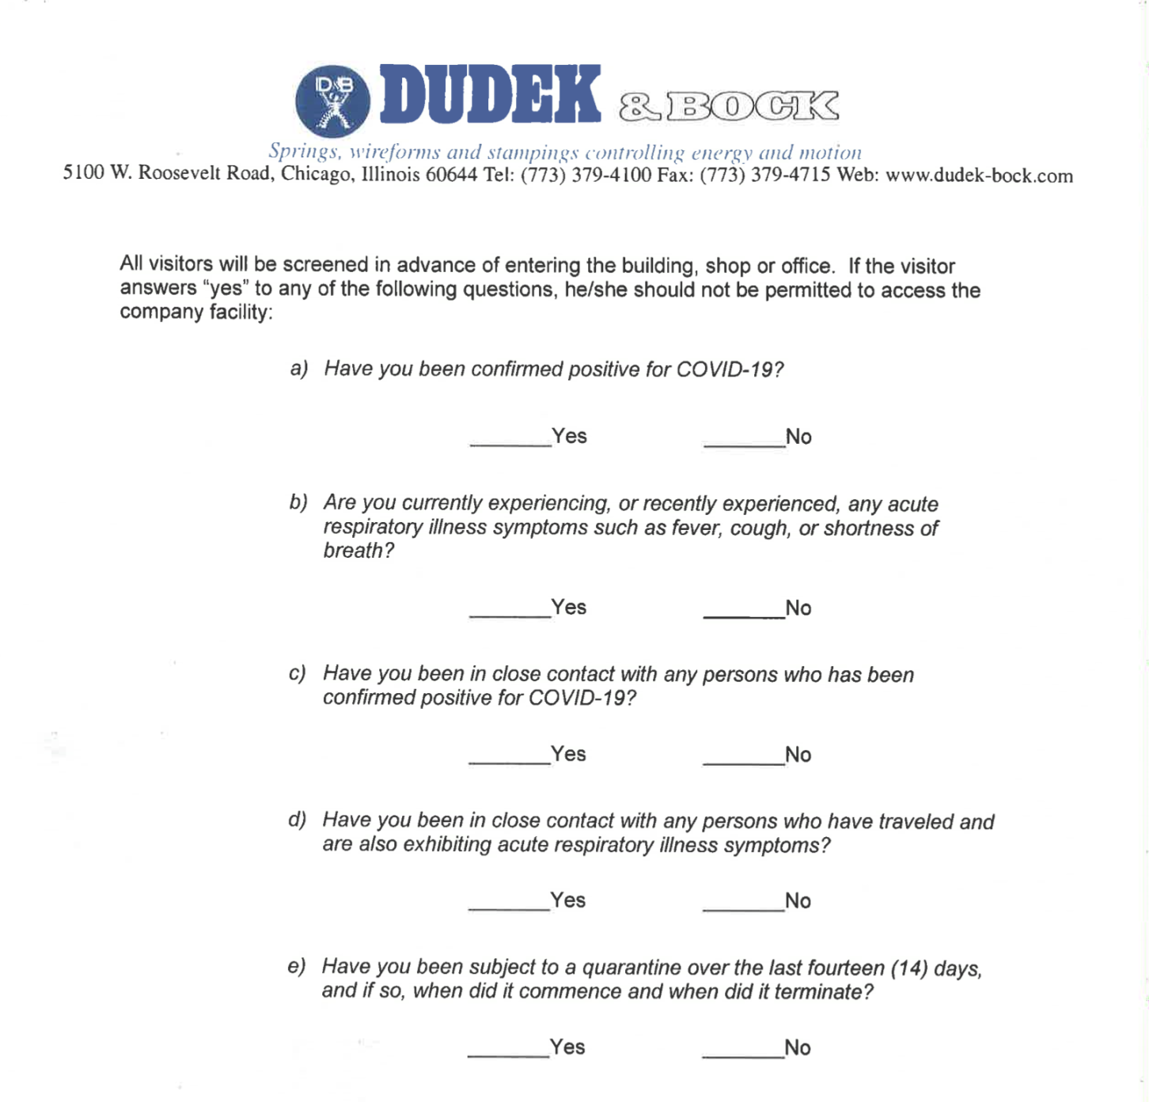

Name____________________________________________

Date_____________________________________________

Signature_________________________________________

Company_________________________________________

Host_____________________________________________

COVID-19 Report & Contact Tracing

Employee testing positive: Clock #:

Job Title:

Department:

Date of positive test result:

Date D&B was notified:

Last date employee was at work:

Employee interviewed on:

Interviewed by:

Symptoms:

Contacts identified by employee:

Action taken:

Follow-up:

Possibility of infection at work:

